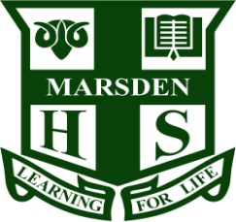

Marsden High School
Principal’s Tour
You and your child are invited to
Marsden High School
on Thursday 15th September or 20th October
at 4pm
for an engaging and informative
tour of the school with our
Principal Mrs Denise Lofts.

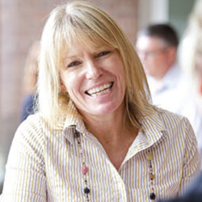

This is a great opportunity to:
- meet the Principal
- get to know your outstanding local High School
- have your questions answered.

Please make bookings with Sharron Walden

Ph 9874 6544, Fax 9858 1716
Email marsden-h.school@det.nsw.edu.au
Winbourne St, West Ryde

We look forward to seeing you there.

