MARSDEN HIGH SCHOOL
Admin Only
Deposit and Payment Code: 044-338
Permission Notes to Mr A.King
Payment Concerns to Mr. A King
Winbourne Street
West Ryde, NSW 2114
Telephone: 9874-6544

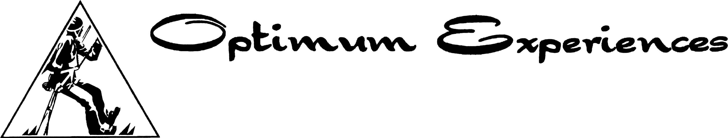

Permission and Information Sheet

Year 11 Crossroads Camp – Jamberoo Valley Lodge
Wednesday 12th June – Friday 14th June 2013

Student’s Full Name : ___________________________________

Year: ___________________ Date of birth : __/__/19__

Home Address : ______________________________________
__________________ Postcode : ______

Parent/Guardian Full Name : _____________________________

Telephone No. Home : _____________ Work : _____________

Emergency Contact Person : ______________________________

Emergency Contact Telephone No. _____________

In the event that your child should need medical attention, please complete the following details :-
Medicare Card Number : _ _ _ _ _ _ _ _ _ _ - __ (place on card)

Medical History
Does your child suffer from Asthma YES / NO
Any allergic condition YES / NO
Skin conditions YES / NO
Diabetes YES / NO
Epilepsy, fits or blackouts YES / NO
Adverse reaction to any drugs YES / NO
Any other illness / disability YES / NO

If the answer was YES to any of the above, please give details (use the attached sheet for Asthma and allergic conditions):-
________________________________________________________________________________________________________________________________________________________________________________________________________________________________________________

Details of any medication currently needed by your child:-
______________________________________________________________________________________________________________

Special Dietary needs : Vegetarian [ ] Vegan [ ] No pork [ ] No dairy products [ ]

Activities :
Do you give permission for your child to participate in the following activities whilst on camp?
Interactive challenge initiatives YES / NO Challenge games YES / NO
Drugs/HIV presentation YES / NO Eagles Nest YES / NO
High wire challenge YES / NO Road Safety Pres. YES / NO
Giant Swing YES / NO Relationship Activities YES / NO
Sock Wrestling YES / NO

If the answer was NO to any of the above, please give details :-
________________________________________________________________________________

________________________________________________________________________________

Rules :
My child understands the rules associated with this camp - Camp Rules, School Rules - and understands the need for these. YES / NO

The consequences of my child breaking any of these rules is that he/she will be given a suitable punishment on camp (isolation, detention, cleaning up, etc.). In severe cases he/she will be sent home at the student’s own cost, with no refund of any part of the camp fees. If your child is sent home, both you and the school will be contacted, and your child will be immediately under suspension from school. This means that you will need to contact the school to make an appointment for both you and your child with one of the Deputy Principals, Ms.Vasilevska or Ms Paczkowski.

I understand the rules, and the consequences of my child breaking the rules. YES / NO

In the event of accident or illness, I authorise the obtaining of, on my behalf, such medical assistance as my child may require including transport via ambulance if necessary. YES / NO

I also undertake to pay any medical fees and/or the cost of any prescription drugs which may be incurred whilst my child is attending the Crossroads Camp. YES / NO

There will be no swimming activities undertaken on this camp.

I give permission for ____________________________________
to attend the Crossroads Camp at Jamberoo from Wednesday 12th – Friday 14th June 2013 under the conditions stipulated above. I also understand transport to and from the venue will be by chartered bus.

signed _________________________ Date __/__/____
(parent / guardian)

